Tenant Satisfaction Survey Winners 2013

£50 Scottish Hydro Vouchers courtesy of DEEAP Ms Prendergast, Kingsway West (Charleston) estate.

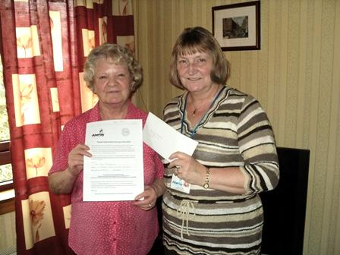
£40 Tesco Voucher courtesy of McGill
Mrs Monaghan, - William Street estate
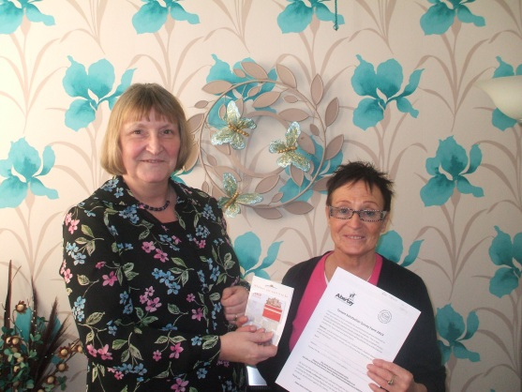
.
£20 Tesco Voucher courtesy of McGill
Mrs Cook, Caldrum Street estate

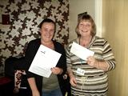
£20 ASDA Voucher courtesy of McGill
Ms Edwards, Fintry estate.

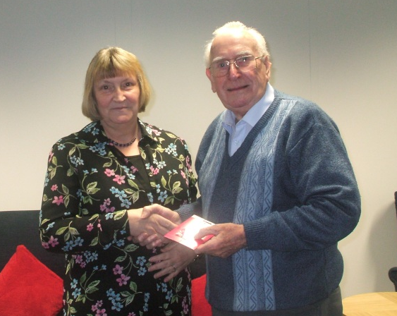
£30 ASDA Voucher courtesy of McGill
Mr Fagan, Dryburgh Gardens estate.

